Search

David Murphy
14 June Growth

5 Appreneur Books That Will Guarantee Results

As competition flares across the App Store, techniques in advertising are becoming progressively

more sophisticated. It’s the appreneur’s job to stay afloat in the market by acquainting themselves with the latest and greatest strategies in e­marketing.

There’s an app for everything nowadays ­ those that are easy to discover, however, are more likely to generate the most downloads. These 5 books offer the essentials in marketing: from successful practices and techniques for both on and off the internet to successful trends in design that'll help you stand out above the rest.

1. Permission Marketing: Turning Strangers into Friends and Friends into Customers

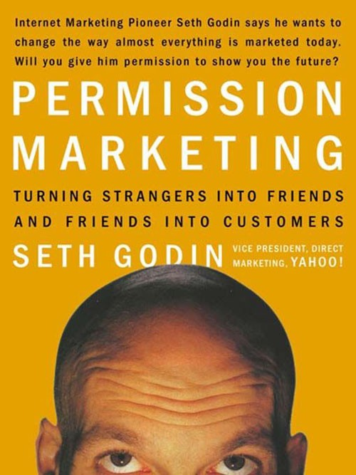
by Seth Godin
Marketing might seem like a dry subject to approach ­ if any book could change that perspective for the better, it’d be this one. One of the pioneers of modern marketing, Godin breaks down the older foundations ­ or what he calls “Interruption Marketing” ­ and rebuilds them with the more modernized conventions of marketing in mind. With his new approach, you’ll learn how to develop trust and long­term relationships with both existing and potential consumers. In fact, entrepreneurs of all industries seeking advice on internet marketing ought to acquaint themselves with his new­age approach to user acquisition.

2. SEO 2016: Learn search engine optimization with smart internet marketing strategies



Search Engine Optimization is a process which aids all developers in maximizing the flow of traffic towards their website. Optimizing your app’s launch page to attract more visitors is an easy and effective way to shape your app’s identity. Clarke is a Google­certified SEO guru whose years of experience as an internet marketing consultant has afforded his prose to be a smooth and effortless read.

3. The Appreneur Playbook: Game­Changing Mobile App Marketing Advice from the Pros

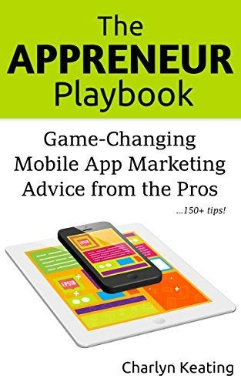

Starting in 2012, from the moment Apple approved her first­ever app for publication, Keating knew she’d be addicted app development. By Nov 2014, she’d have published a total of seven apps on the store ­ most of which she coded herself. Yet she struggled to live comfortably with the small profit she made:

“Two years into it, I had learned a lot. But real success still eluded me. I was making just a few hundred dollars a month— not enough to pay the rent. What was I missing?”

She set out to find the answers herself, and she sought them through the expertise of successful developers and appreneurs. She collected all the invaluable information she uncovered from millionaire developers in this 150 page book for the convenience of any other appreneurs that found themselves in a situation similar to her own.

4. Tapworthy: Designing Great iPhone Apps
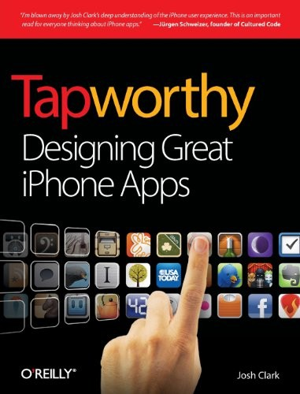
by Josh Clark

This is a must­read for anyone interested in iOS development. Clark filled every page corner­to­corner with insight on various navigation paradigms and the advantages and disadvantages of each, app icon design, alerts and notifications, app launching and so much more. You'll also find transcribed interviews between great successors in the app world like Gowalla CEO Josh Williams and both the Firefox browser and Facebook App creator Joe Hewitt.

Note: This book will not teach you how to code in Objective C.

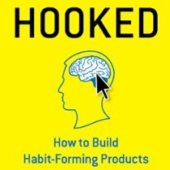

by Nir Eyal

Nir Eyal answers the question of “Why do some products capture widespread attention while others flop?” and “What makes us engage with certain products out of sheer habit?” in this research­intensive book. His model about viral loops ­ the steps users take from installing your app to sharing it with others ­ is broken down into four major questions:

1. How does the loop initiate?

2. Once the user becomes aware of their need for your product, what is the quickest performable action they can do that in turn rewards them?

3. How are they rewarded?

This book has as much to do with behavioral psychology as it does with design, and justifiably so. By virtue of what the book’s title promises, Eyal seems to understand how to fight decaying user retention rates and “hook” users onto your app.

0

You might also like this articles

Dominick Wojtas
21 May

Why apps get rejected

The App Store is every iOS developer’s best friend until your app is rejected, and then it quickly becomes your enemy. Ensuring your app will be accepted by the App Store review process before submission is essential for every app developer. A rejected app can not only be a bad finish to a smooth development process but it can also cause unnecessary delays.

0
Dominick Wojtas
13 October

Does My Company Need a Mobile App or a Mobile Website?
Mobile apps and mobile websites both benefit the modern marketer. In previous years, however, experts have debated the impact of selecting one over another. Marketing strategies take time to fully form, and not every business impacts customers through multiple channels.

0

